Project Design Phase
Solution Architecture

Date | 29 July 2026
Team ID
Project Name | Plugging into the Future: An Exploration of Electricity Consumption Patterns
Maximum Marks | - Marks

Solution Architecture:
Solution architecture for "Plugging into the Future: An Exploration of Electricity Consumption Patterns" is the process of designing an effective data analytics solution that transforms raw electricity consumption data into meaningful insights through interactive visualizations. It bridges the gap between complex electricity datasets and informed decision-making by using Tableau dashboards.
• Analyze electricity consumption data to identify trends, seasonal variations, regional differences, and the impact of significant events such as the COVID-19 pandemic.
• Present interactive dashboards, charts, maps, and key performance indicators (KPIs) that enable stakeholders to easily understand electricity consumption patterns.
• Define the data flow, visualization requirements, dashboard components, filters, and analytical features required for effective electricity consumption analysis.
• Provide a scalable and maintainable analytics solution that allows users to monitor electricity consumption, compare state-wise performance, generate reports, and support data-driven energy planning and policy decisions.
Example - Solution Architecture Diagram:
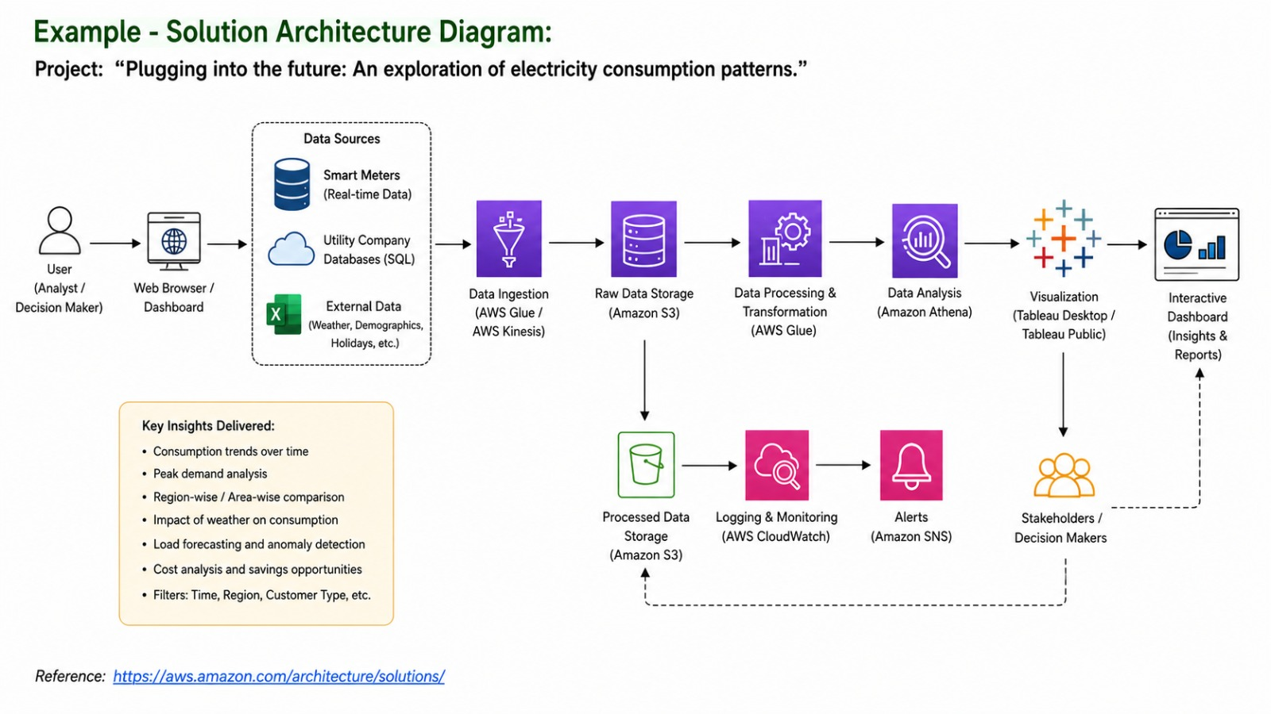

Figure 1: Architecture and data flow of the voice patient diary sample application

